Employee Onboarding Checklist

Task | Done | Not applicable | Note
New hire paperwork checklist
Signed and documented offer letter and contract, outlining the terms and conditions of employment | ☐ | ☐
Tax forms | ☐ | ☐
Copies of identification documents (e.g., passport or driver’s license) | ☐ | ☐
Emergency contact information | ☐ | ☐
Benefits enrolment forms (including health insurance, pension, and other benefit plans) | ☐ | ☐
Non-disclosure agreement (NDA) or confidentiality agreement | ☐ | ☐
Onboarding tasks
Input new hire’s information into the payroll system accurately | ☐ | ☐
Create profiles in the necessary internal systems | ☐ | ☐
Arrange office access cards or passwords | ☐ | ☐
Set up all IT accounts (including email accounts, software installations, and access to shared drives) | ☐ | ☐
Conduct health and safety training | ☐ | ☐
Welcome pack for new employee
A company overview that includes mission, vision, values, and organizational structure | ☐ | ☐
An employee handbook outlining policies, procedures, and code of conduct | ☐ | ☐
The first week’s schedule with a full orientation and introduction phase itinerary | ☐ | ☐
A directory of relevant team members, departments, and their roles | ☐ | ☐
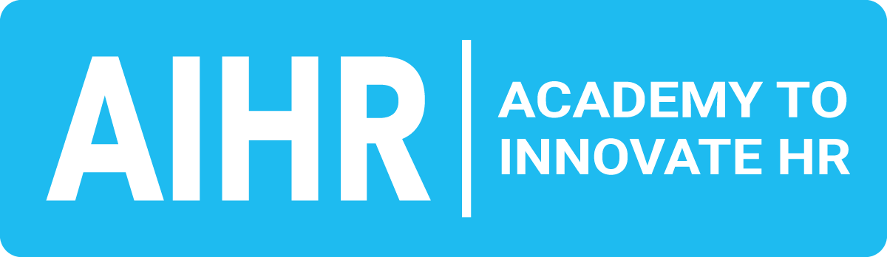
aihr.com
Task | Done | Not applicable | Note
Welcome announcement for new employee
Email or a notice on the intranet introducing the new hire, their role, and background | ☐ | ☐
A scheduled meeting with direct teammates and supervisors, either in person or virtually | ☐ | ☐
Add new employee to the organizational chart | ☐ | ☐
Mentorship or buddy system implementation
Pair a new employee with a seasoned team member to ease the transition, and to offer guidance, insights, and a friendly point of contact | ☐ | ☐
Continuous feedback and support
Schedule regular check-ins including HR and immediate supervisors during the first few months to provide continuous support and address any concerns | ☐ | ☐
A formal review after the initial 90 days to assess progress, alignment with company goals, and set further development plans | ☐ | ☐
Cultural integration and social engagement
Provide insights into the company culture, traditions, and values through cultural onboarding sessions | ☐ | ☐
Organize informal gatherings or team-building activities to facilitate social integration within the team | ☐ | ☐
Professional development and training plans
Depending on the role, lay out specific training or development courses that align with the job description and future growth within the organization | ☐ | ☐
Offer access to online platforms or in-house training materials to encourage continuous learning | ☐ | ☐

aihr.com

Task | Done | Not applicable | Note
Accessibility and inclusivity measures
Ensure that any specific requirements related to disabilities are addressed | ☐ | ☐
Provide training on diversity and inclusivity to create a respectful and supportive environment | ☐ | ☐
Exit strategy from the onboarding program
Create a planned transition from the onboarding program into full engagement with the team, marked by clear milestones and communicated expectations | ☐ | ☐
Gather insights from the new hire on their experience with the onboarding process, for continuous improvement | ☐ | ☐

aihr.com


