Employee Satisfaction Survey
This is a survey for employees of [COMPANY NAME]. The aim is to understand the working conditions, professional expectations, and overall job satisfaction of all our team members.

Your feedback is anonymous. Filling in the survey should take you a maximum of 5-10 minutes.

Your responses will help us identify areas that need improvement and improve the working experience for everyone.

How long have you been working at the company?
< 1 year | 1-2 years | 2-5 years | 6-10 years | 10+ years
☐ | ☐ | ☐ | ☐ | ☐

Please rate your satisfaction with the following aspects of your experience as an employee at our company.
Scale | Extremely dissatisfied | Dissatisfied | Neutral | Satisfied | Extremely satisfied | Not applicable
Your job overall | ☐ | ☐ | ☐ | ☐ | ☐ | ☐
Having your work recognized and appreciated | ☐ | ☐ | ☐ | ☐ | ☐ | ☐
Communication from management | ☐ | ☐ | ☐ | ☐ | ☐ | ☐
Access to the tools and resources to perform your job effectively | ☐ | ☐ | ☐ | ☐ | ☐ | ☐
Opportunities to provide feedback to your supervisor | ☐ | ☐ | ☐ | ☐ | ☐ | ☐
Opportunities for professional growth in our company | ☐ | ☐ | ☐ | ☐ | ☐ | ☐
Work-life balance | ☐ | ☐ | ☐ | ☐ | ☐ | ☐
Compensation & benefits | ☐ | ☐ | ☐ | ☐ | ☐ | ☐

How likely are you to recommend our company to a friend as a good place to work?  (1 = Extremely unlikely, 10 = Extremely likely) | 1 | 2 | 3 | 4 | 5 | 6 | 7 | 8 | 9 | 10
 | ☐ | ☐ | ☐ | ☐ | ☐ | ☐ | ☐ | ☐ | ☐ | ☐

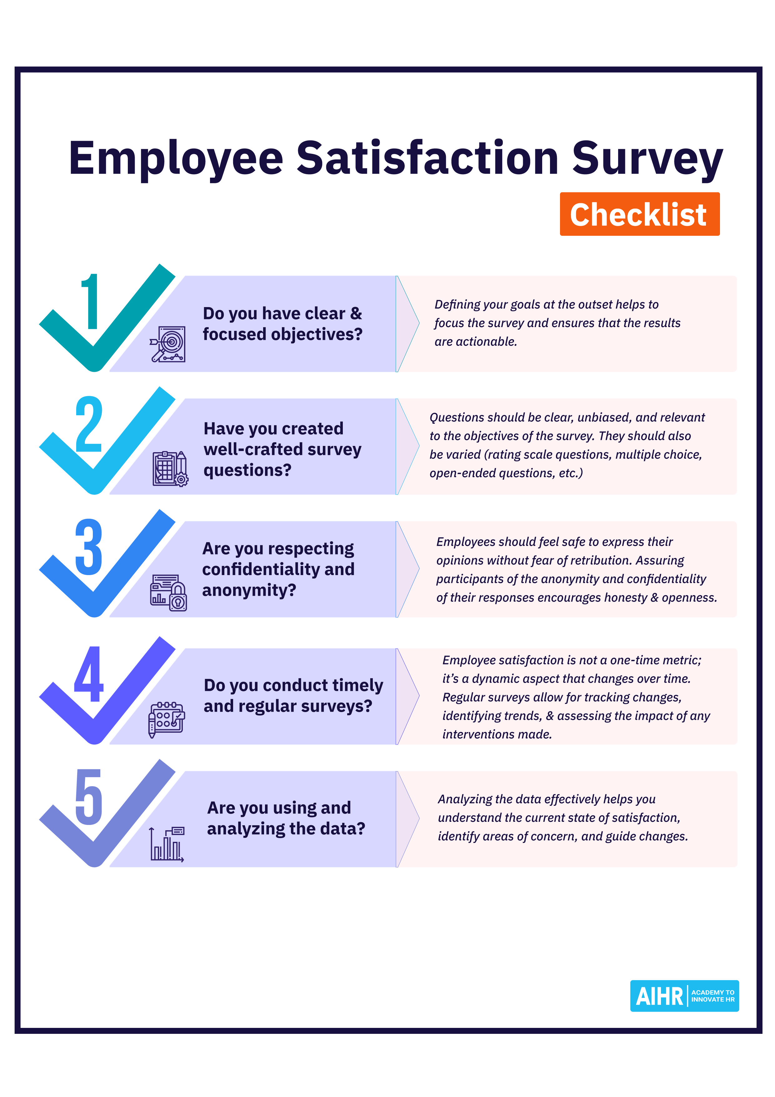
aihr.com



